The Sierra Railroad
By Dan Carrion

Prior to the discovery of gold at Sutter’s Mill, the area that would become the counties of Tuolumne and Calaveras were little known and not well developed. The higher elevations were completely impassible in winter, and had little traffic even in summer. The lower elevations were rocky and unsuitable for good farming or year-round feeding of cattle. Once the Gold Rush started, there was great excitement in the area, and one early miner in the Columbia area found a nugget that was worth $3,000 at the time. Instantly the area was populated. The method of transport generally in use for the early resident was either ox cart or mule team, and the early roads of the day were barely discernable, but soon became well-travelled and quite popular. Stage lines began operating, but travel was less than ideal, hampered by deep mud in the winter, flooded creeks in the spring, and thick dust in the summer. No matter what time of the year, travel was precarious because the roads were carved out of hillsides and laced with cliffs in many locations, and there was always the threat of an encounter with Black Bart or one of his contemporaries.

By the 1890’s there were still several profitable mines located in the southern mines around Sonora, Jamestown, and Angels Camp. Mining kept many miners employed in dangerous hard rock deep shaft mining operations, as placer mining had long since died out, or had been made illegal as in the case of hydraulic mining. Some local men were employed as teamsters hauling freight to and from the mines and the various far flung townsites. Lumberjacks worked in the mountain forest areas, but labored severely using twelve horse freight wagons to get their timber to market. Others were employed as blacksmiths repairing the equipment used by the teamsters, miners, and lumber men. Every town still had its collection of saloons and hotels. But, it was inescapable that the glory days of the Gold Rush has long since passed. However, there was a change coming on the horizon.

A new railroad, the Sierra Railway, would soon be built in this section of the Mother Lode, and with it would come new industries and new opportunities. Hauling lumber, freight, and ores from the mines was expensive using ox teams, horses, and mules, eating up nearly all the profit from the mining business. But a railroad would be cheaper and faster. The new railroad and its founders would ultimately change the local scene forever in many ways, and it would provide employment and survival for the local residents long after the mines had played out.

The cast of characters of this saga starts with Thomas S. Bullock. Fresh from Arizona, Bullock had most recently built the Prescott and Arizona Central Railway operating from Seligman to Prescott, the first railroad to reach Prescott. Unfortunately, bad luck with washouts, minimal construction quality standards, and a lack of business (caused by competition from the newly arrived AT&SF RR) forced the P&AC Railway to cease operation in 1893, after only a few years. Bullock had made considerable money in previous railroad experiences in Mexico, so undeterred by the seeming defeat of the P&AC Railway, Bullock next came to the California Mother Lode to try his hand at again building a railroad.

In 1896, Bullock scouted the southern mines area and decided to build a railroad commencing at Oakdale (the nearest available Southern Pacific Railroad connection) and continuing some distance into the mountains. The first eastern terminus would be located at Jamestown, much to the consternation of the people of Sonora who wanted it to terminate in their town. Ultimately, the Sierra Railway would extend past Jamestown to Sonora, Standard, Tuolumne, and to Angels Camp. Connections with other railroads owned by the same cast of characters would extend it to Hetch Hetchy Valley and nearly to the crest of the Sierras.

The next character in our story is William Henry Crocker, who at the time was the president of Crocker Bank, one of the most powerful banks in California. Crocker would be largely responsible for financing the rebuilding of San Francisco after the horrible earthquake of 1906. William was the son of Charles Crocker, one of the “Big Four” who built the Central Pacific Railroad from Sacramento to Promontory, Utah, where it met the Union Pacific to form America’s first transcontinental railroad. It was Charles Crocker who ran those construction crews and was responsible for hiring the Chinese workers who ultimately saw the project to completion.

William H. Crocker was also the brother-in-law of Prince Andre Poniakowski, a Frenchman who was a member of the Polish Royal family. He was married to Crocker’s wife’s sister, Elizabeth Helen Sperry (of Sperry Flour fame). Helen’s uncle, James Sperry, owned vast quantities of forest acreage in the area. Prince Poniakowski (known as The Count) and William Crocker in 1896 formed the California Exploration Company, using French and English money to buy up timber land, mining interests, a marble quarry, and other businesses in the hills around Calaveras and Tuolumne counties. Upon learning of Bullock’s plans to build a railroad, and seeing the great advantage they would have by availing themselves of its service, they were quick to agree to finance the venture. And thus, our story truly begins.

Bullock brought all of the salvaged railroad (rails, locomotives, and other equipment) from the Prescott and Arizona Central, including the now famous Rogers Locomotive Works Number 3 locomotive, to Oakdale. The railroad was incorporated on February 1, 1897 as the Sierra Railway Company of California, and construction began on March 2, 1897. The West Coast Construction Company (created expressly to build the railroad and owned by Bullock) arrived in Oakdale ready to proceed with grading. Using 300 head of horses, 400 men, and many Fresno Scrapers working ten hours a day seven days a week, they proceeded alongside the mud swamped Sonora Road and built the railroad.

Bullock’s brother-in-law, Sidney Freshman, would be the fourth character in our story. He and Bullock had worked together on projects in New York, and they meshed together perfectly. Bullock and The Count were the dreamers, Crocker was the banker and financial wizard, and Freshman was the practical man who would run the day-to-day operations of building and operating the railroad.

The idea initially was to get rails to the mines as quickly as possible. But a secondary goal was to take a line above Angel’s Camp to the Calaveras grove of Big Trees, which of course, was owned by James Sperry. A further extension would reach the Tuolumne Grove of Big Trees, the area around which was largely owned by Bullock. Both extensions would provide ready-made tourist business for the railroad.

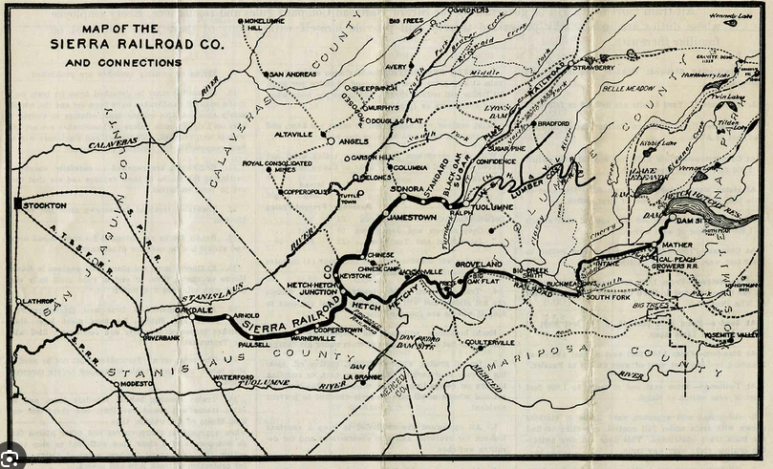

The line was completed to Jamestown by November 8,1897. Freight haulers (and nearly everyone from Sonora) instantly complained that they would all be put out of business, or that the railroad would surely fail due to shoddy construction, or that this giant of a corporation (a bit of exaggeration from the newspapers of the day) would swallow the entire foothill economy. But, in Jamestown there was a huge celebration when the first train arrived. The town usually boasted a population of around 500 people, but on that day over 4500 people gathered to see the train arrive. Women screamed, horses reared, the band paraded down the street, and people shouted and waved their hats at the spectacle of Jamestown becoming a railroad town!

Ultimately, the freighters were not put out of business, little railroad didn’t fail, and the economy of the area was improved by its presence. The area was rich with possibilities in terms of passenger service and freight. In fact, the railroad was quickly extended. If the freight haulers were upset when the railroad reached Jamestown, they must have been livid when it reached Sonora in 1899, and Tuolumne City in 1900! Our cast of characters had big plans, and those plans were quickly being put into action.

In Jamestown, an enterprising man named Captain W.A.Nevills built a plush hotel next to the new Jamestown Depot. Captain Nevills managed several mines in the area, most importantly the Rawhide Mine Stamp Mill and Chlorination Works, and he was eager for the new railroad to succeed. The grand new Nevell’s Hotel became the place to stay for passengers wanting an upscale residence while in the area. It also became the meeting place for local people for either business or pleasure. Sadly, the opulent hotel burned in 1915. All the residents escaped unscathed, including a drunk who had to be carried down from the third floor. Fortunately, the hotel’s quick-thinking bartender removed all of his best liquor bottles and stacked them on the railroad tracks outside the hotel before the bar area was consumed. The hotel was never rebuilt.

The two story Jamestown Depot was home to the railroad’s corporate and operating headquarters. It was built in a Chinese style, as was the Nevills Hotel, and the Sonora Depot, all designed by British architect George Richardson using inspiration from Prince Poniakowski. Jamestown yard boasted a roundhouse, machine shop, foundry, car repair shop, water and fuel tanks, and all the other functions necessary for continued railroad operations. This would be the main shop for the Sierra Railroad until the late 1950’s. The depot burned to the ground in 1913, and all of the early records, including all of William Newell’s engineering drawings and notes, were lost. The depot was soon rebuilt, still two stories tall, but without the Chinese style.

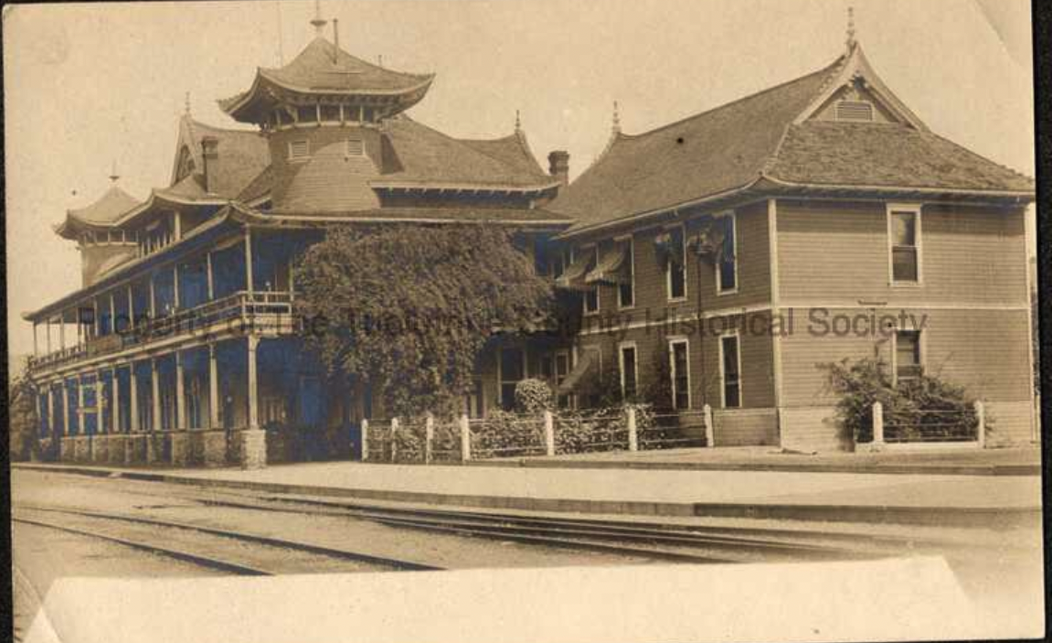

The Hotel Nevills, with the Jamestown Depot to the right.
Both burned down, the depot burned twice.

In addition to the timber lands that they already owned, Crocker and Poniakowski purchased more timber land further up the in mountains. By 1899, with the help of a few other backers, they created a new lumber company. The West Side Flume and Lumber Company was formed in Tuolumne City (previously known as Summerville), where a huge mill was built. This lumber company was complete with a narrow gauge railroad to serve it, first called the Hetch Hetchy and Yosemite Valley RR, and finally called the West Side Lumber Co RR.
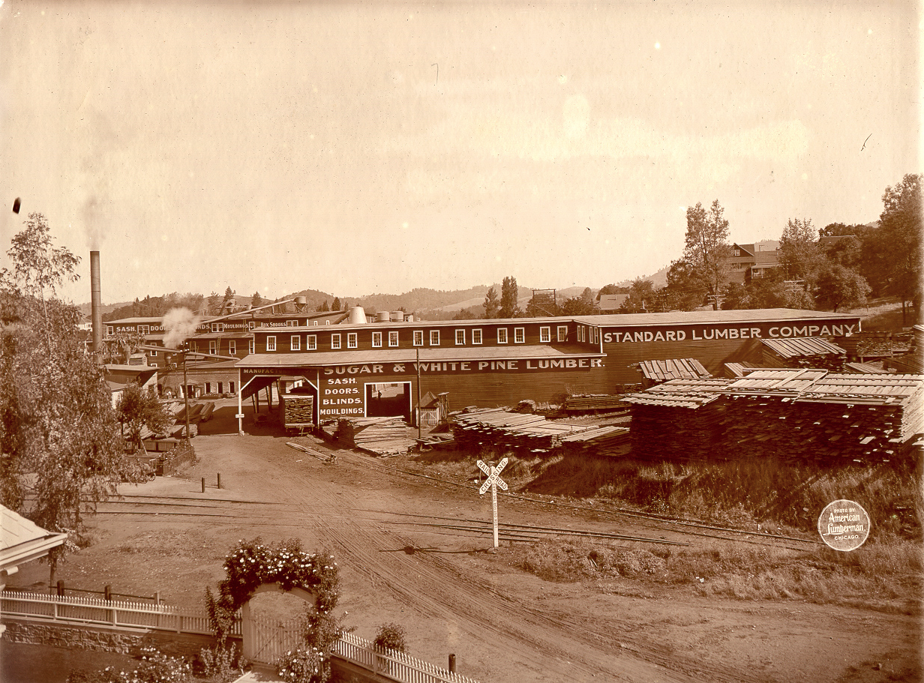

Standard Lumber Company Mill, Sonora, Ca

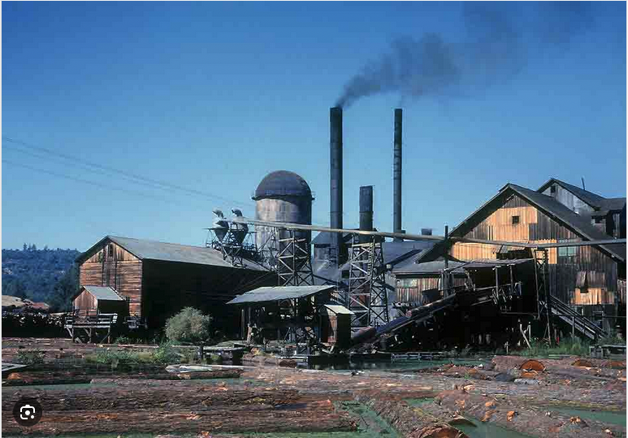

West Side Lumber Company Mill, Tuolumne, Ca.

In 1901, our heroes created another lumber company by buying up several existing mills around Sonora and building a few new mills as well. The company was called the Standard Lumber Company, and they built two railroads, the 30-inch narrow gauge Empire City Railway, and the standard gauge Sugar Pine Railway to serve their needs. These two lumber companies and the three railroads that served them would feed lumber to the Sierra Railroad for the next 80 years or so, and would be the railroad’s most steady source of income.

Ultimately, our characters would sell both the lumber companies and the railroads that served them. The West Side Flume and Lumber Company was sold in 1903 to a group of Michigan lumbermen who changed the name to West Side Lumber Company. The Standard Lumber Company was sold to the Pickering Lumber Company in 1910. Pickering also purchased the West Side in 1925.

A fifth character joined our story. William H Newell was an engineer who would be responsible for most of the Sierra Railroad’s track engineering. It was Newell who created the routes to Sonora, Standard, and Tuolumne, and it was Newell who figured out the torturous grade to Angel’s Camp, after many other railroad engineers said it couldn’t be done. Newell’s curvaceous Angel’s route contained several switchbacks and a huge wooden bridge across the Stanislaus River. Because of the tight curves, a couple of very short passenger cars were special ordered from the Holman Car Company. These cars would play an important role in the railroad’s later fame and success, but more on that later. The railroad also purchased three Shay, one Heisler, and two Baldwin locomotives to operate specifically on the Angel’s Branch, due to the steep grades and sharp curves.

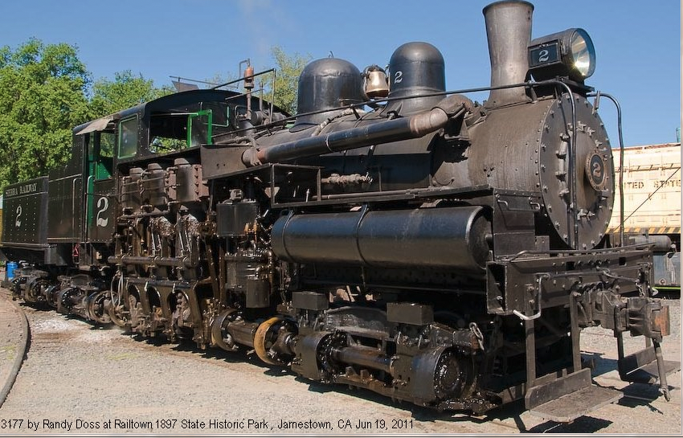

Sierra Railroad Shay #2, not actually operated on the original railroad, came in 1966.
Still stored in Jamestown.

The Sierra Railroad became so successful that in 1904 the AT&SF built a branch line extending from Riverbank to Oakdale to take some of the freight traffic away from the Southern Pacific. When SP later abandoned its line north and south of Oakdale, it maintained trackage rights over the AT&SF to afford itself a share of the business. The Sierra was regularly hauling passengers, grain, coal, crude oil, dynamite, and mining and lumber machinery into Jamestown and the surrounding area. Outbound freight included passengers, lumber, marble, ore and ore concentrates, and other locally produced goods.

Our characters were not finished yet. The success of the Sierra prompted them to believe that they could crest the Sierras through a four-mile long tunnel, and make a connection with the Virginia and Truckee in Nevada. They also felt that there was a huge tourist business waiting for them in Yosemite. All they needed was to extend the railroad to the park. The plan was to go through Hetch Hetchy Valley (before construction of the dam) and some 20 miles of track was actually laid in that regard. In early 1906, 6 miles of track on the new Yosemite Short Line was in service.

On April 17th of 1906, we find our main characters are gathered in San Francisco to sign legal documents extending the railroad and insuring funding for those extensions. The next day, April 18, 1906, changed that forever. The San Francisco Earthquake struck at 5:18 am, and that would lead to wrecked finances for both Crocker and The Count. All dreams of reaching Yosemite, the Yosemite Short Line RR, and the high Sierra crossing to Nevada died that day. Prince Poniakowski was forced to repay the money from the French investors, requiring that he sell all of his holdings in the area. He returned forever to France.

Sadly, on a hot night in October 1910, the Jamestown roundhouse burned to the ground due to spontaneous combustion of a pile of oily rags. Two locomotives inside the roundhouse (#4 and #9) were badly damaged and a track car was totally burned. The railroad’s six machinists lost all of their tools. Damage estimates were over $10,000. But this would actually benefit the railroad because a new roundhouse was soon built, complete with electric lighting and large drop pits for locomotive maintenance and repair. The two damaged locomotives were soon repaired and continued working in Sonora and Jamestown.

In 1913, after a long and bitter fight with John Muir’s Sierra Club, the City of San Francisco was finally allowed to build a dam in the Hetch Hetchy Valley, impounding drinking water for the city. In 1915, a 68-mile-long extension off of the Sierra Railroad, to be called the Hetch Hetchy Railroad, was approved for dam and aqueduct construction purposes. Construction began on the Hetch Hetchy Railroad at milepost 26 on the Sierra mainline in 1916. It used some of the previously built Yosemite Short Line’s road grade. World War l slowed the work before the new railroad could reach the dam site. The HHRR owned their own six locomotives, but the Shay locomotives owned by the Sierra were often rented, as were some of the Sierra’s cars. This was a boost for the Sierra, because government regulations, demands by labor unions, and the high cost of modern extraction and purification techniques caused most of the local mines to close by the end of World War l, leaving very little mine freight for the Sierra to handle. By this time the Sierra RR ran one train a day up and down the line. This was a huge reduction from the six daily trains that ran in the early days.

In 1921, the Turlock and Modesto Irrigation District wanted to build Dom Pedro Dam on the Tuolumne River to supply the area with water. The Sierra built an eight-mile-long spur that ran from Rosasco to the dam site to haul equipment, machinery, men, and supplies. The Atlas Rock Company of Oakdale was a supplier of gravel and other materials for dam construction. The Sierra wisely sluiced the sand and gravel aggregates before loading them in cars and transporting them to the construction site, recovering a considerable profit in gold.

The Oakdale Irrigation District’s Melones Dam water storage and power production construction project on the Stanislaus River also provided business for the Sierra. The dam was later raised 15 feet, and again the Sierra was there. The railroad bought new locomotives and cars to again haul gravel from the Atlas Rock Company near Oakdale. A spur was created from just outside Jamestown and lead to the dam site. This was a steep grade with switchbacks, necessitating the use of the railroad’s Shay locomotives.

The Stock Market Crash of October 1929, and the ensuing Depression hit the railroad hard. Thomas Bullock had died in 1919. C.N. Hamblin, a long time Sierra manager, was made General Manager of the railroad in 1917, and Bullock’s son, J.T.(Jack) Bullock, joined the board. The Pickering Lumber Company and the West Side had shut down, leaving little freight for the railroad to haul. The railroad raised freight charges on the remaining traffic, which forced local ranchers and businessmen to buy trucks to haul their goods to market instead of paying the railroad’s higher rates. Profits plummeted. These were hard times for the railroad, demonstrated by the suicide of President Hamblin in 1930, who apparently just couldn’t deal with all of the railroad’s problems. J.T. Bullock would become the railroad’s General Manager. By 1932, the Sierra was in bankruptcy.

In 1937, the railroad was sold at public auction and the remaining bonds and debts were paid off. The lumber companies opened again as the Depression abated, and the Hetch Hetchy dam was raised, making the Hetch Hetchy Railroad a necessity. The HHRR was soon reconditioned. Unfortunately, the Depression’s damage had been done, because the Sierra lost the mail contract into the mountains, and was forced to end passenger service entirely, abandoning the Angel’s Branch by 1939.

In 1937, the Sierra started running tourist specials and railfan trips over the line. Steam trains were quickly going out of style, and organizations like the Railway and Locomotive Historical Society and the National Railway Historical Society were striving to preserve what they could, and to highlight railroads still operating steam. By the 1950’s most railroads had deleted steam locomotive from their rosters, leaving the Sierra RR as a living breathing museum in action. The railroad became a favorite of these railfan groups, and many excursions were held on the line. Seeing an opportunity, the railroad began running a dinner, dancing, and drinking train called the “Supper Chief” starting in 1971. It was said that by the time the train arrived in Jamestown, the engineer and conductor were the only sober people on the train. The lumber mills provided a steady stream of freight, and Hollywood movies and TV shows were being produced in the area regularly…more on that later.

Inevitably, in 1955 the first diesel electric engines were purchased by the railroad. Cheaper to operate, with less maintenance needed and less crew needed, the diesels pushed the steam locomotives out of service, relegating them to special trains only. The railroad bought two Baldwin Lima Hamilton S12 switchers and immediately put them to work, operating out a new engine shop in Oakdale, where all operational facilities were moved.

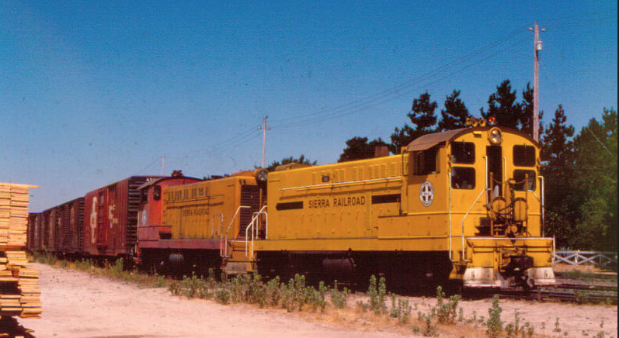

Sierra Railroad’s first Baldwin S12 diesel engines, Numbers 40 &42

The Jamestown roundhouse facility instantly became superfluous. The railroad held a 13 car “Farewell to Steam Special” on April 17, 1955 from Oakdale to Jamestown. The train was sponsored by the Pacific Coast Chapter of the Railway and Locomotive Historical Society, and was pulled by two Sierra steam locomotives, the big 2-6-6-2 Number 38 and 2-8-0 Number 28.

The railroad continued to operate, even as business dwindled, and was again in dire financial straits by the late 1970’s. Charles Crocker lll (grandson of William H. Crocker) and the Crocker family who now owned the railroad, decided to get out of the railroad business, a business that his family had helped bring across the country to California in the late 1860’s. He decided to split the railroad away from the historic Jamestown Depot and Roundhouse area. He sold the railroad to a Chicago businessman, who tried running the railroad remotely, but the costs and low returns didn’t prove profitable. Before long, the railroad was again for sale.

In 1995 it was sold to Sierra Pacific Coast Railway. Owner Mike Hart put a small fortune into reconditioning the railroad and building new facilities in Oakdale. A 30-year contract with Sierra Pacific Industries guaranteed at least 1,896 car loads per year from their Fibreboard Inc. plants in Chinese Camp and Standard, no matter whether they actually hauled that many cars or not. This would guarantee the railroad a steady income for many years. The railroad soon embarked on a rebuilding and refurbishment program. Using their own funds, plus money from state grants, the railroad rebuilt the roadbed and purchased newer EMD locomotives to replace the now antique Baldwin diesels.

In 1981, the California State Department of Parks and Recreation opened the California State Railroad Museum in old town Sacramento. This was a huge undertaking and it quickly became a world class railroad museum, one of the finest in the country. In 1982, Crocker and Crocker Associates put the Jamestown Roundhouse, freight depot, (an arson fire destroyed the Jamestown depot in 1978), 6 miles of track to Chinese Camp, and 26 acres of the railroad’s Jamestown property up for sale. It was hoped that the California State Railroad Museum would take the property over, but because of the enormous trouble and cost they had gone through to build the Sacramento facilities, they weren’t interested.

Strangely, a San Quentin Prison inmate named Bruce Cassasa, who was a huge train buff, had formed an organization with other train buffs called the “Friends of the Sierra Railroad.” From his prison cell, Cassasa had written (using black shoe polish and water) long letters to each and every state senator and legislator. He wrote 3 letters to each, urging them to save the Sierra’s Jamestown facilities. Together with letters from the “Friends,” they convinced Governor Jerry Brown and the State Legislators to allocate funds to save the Sierra Roundhouse and its environs. Crocker Associates received $750,000 for the property and donated $1.2 million worth of equipment. “Railtown 1897”, which was the name given to the area by Crocker in the late 1970’s, would now become a state park, ultimately under the jurisdiction of the California State Railroad Museum in 1996.

The Sierra Railroad merged with the Yolo Shortline RR in 2003, and the combined entity became the Sierra Northern Railway. SNRY is comprised of the Sierra Railroad, the Skunk Train in Willets, the Mendocino Railway California Western Railway in Fort Bragg, California, The Sunburst in Santa Paula, Ca., and the Sacramento River Fox Train which operates dinner trains and other excursions out of West Sacramento Ca. The Sierra Railroad continues operations hauling lumber, propane, and other commodities, and there are some projects on the horizon that may provide even more freight revenue. Additionally, the railroad uses its diesel electric locomotives as stationary power generation sources during times of peak draw on California’s electric power grid. So, its future seems secure.

This sounds like we have reached the end of our story. For any normal railroad, this WOULD be the end of the story, but not for the Sierra. There is a bit more to share. After the turn of the century, silent movies became popular. Since most of the very early day film making equipment was manufactured in the New York area, that is where film making was centered. If you are making a film about the East Coast, then New York is perfect. But, film people wanted to make films about the west, with western themes, especially the “Old West”, so New York just doesn’t work. And the weather doesn’t cooperate much either. Where better to take your film production crew than sunny California!!! And that is exactly what happened.

Early silent films had many locations and themes. But, the old time Western movies proved very popular with early day movie goers. One of the very first moving pictures was of a gunslinger pointing his gun at the camera and pulling the trigger, a harrowing experience for the average movie goer of the day! The movie industry ultimately settled in the LA area, but that didn’t look like the old west. They needed someplace that had the correct ambiance, the correct patina, the correct look and feel, and the correct amount of money needed to go there and film. It couldn’t be too far away because that would raise the costs. And if it could double for many different types of locations, even better. It wasn’t long before Tuolumne County became known as the perfect (and closest to LA) duplicate for film locations from the Appalachians, the Great Plains, the Midwest, the Rockies, the Ozarks, and the South. In fact, Tuolumne County’s towns could be “set dressed” to look like any town in the US. For film makers, this was a gold mine.

The Sierra Railroad was used in hundreds of films over the years, at least 300 can be verified. There were many more, but the early film stock was made of nitrocellulose, and it breaks down over time, even catching fire. Most of the very early day silent films have been lost because of this, so it is now impossible to determine how many of those films used the Sierra Railroad. The first known film crew to use the area
was for a production called “The Half Breed” starring Douglas Fairbanks, a huge box office draw in 1918. He and his wife Mary Pickford, along with Charlie Chaplin and DW Griffith, would later create United Artists Studios. The film was shot in an area of old growth redwood trees now known as the Calaveras Big Trees State Park, but the actors and crew stayed in Angel’s Camp, arriving (how else?) via the Sierra Railroad.

By the early 1920’s so many film crews came to the area that Sonora businessmen created the Sonora Motion Picture Cooperative to fund marketing efforts to promote their county to film companies. They created a very detailed price list of everything a production company could need from meals and lodgings to labor rates and transportation. Even the costs of lumber, hardware, location fees, and much more was included in this list. This was a great innovation and it made life very easy for a producer budgeting a film to figure out the costs of production in Tuolumne County, just by referencing the list.

Early film crews had to only look around LA for old time steam locomotives and cars, as they were abundant. But once the Depression hit, those old locomotives and cars were retired and scrapped. Suddenly, the Sierra steam locomotives and old wooden cars were in demand. Especially in demand were the Holman shorty cars (Combine Number 5 and Chair Car number 6) made for the Angel’s Branch. They would be made famous by countless films and TV shows over the next 80 years or so. The railroad wisely saw this as a benefit, so they kept the cars in good condition and the executives were eager to help the movie producers by altering or allowing the locomotives and cars to be altered in accordance with the needs of the film. Paint schemes, different stacks, and other “changes” made the equipment become different from their normal appearance. Even the lettering on the locomotives and cars would be changed to represent the railroad called for by the script.

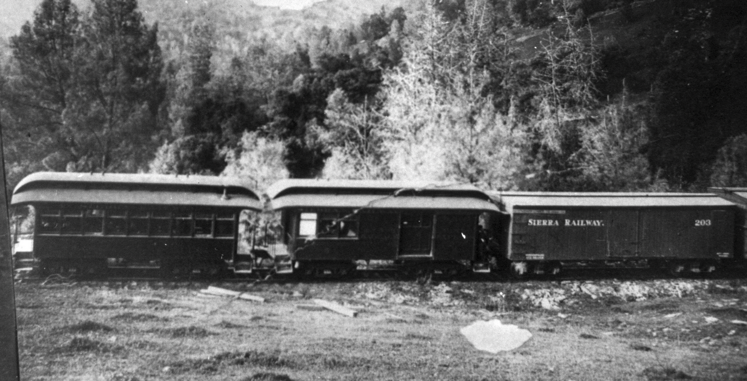

Sierra’s former Angel’s Branch “shorty cars” Combine #5 and Chair Car #6.

Many Sierra locomotives were used in films over the years, but two were the main stars. The Number 18 is a 50 ton 2-8-0 built by the Baldwin Locomotive Works for the Sierra Railroad in 1906. It had already received some changes to its appearance, due to upgrades in its power production capabilities before it was first used in films. But the biggest star of all the Sierra locomotives is the little Rogers Locomotive Works Number 3, a 4-6-0 built in 1891 for the Prescott and Arizona Central RR. It is arguably the most photographed locomotive in history, having done extensive film and TV work. The railroad regularly used Number 3 until 1932, when she was semi-retired from active duty. She was ignominiously parked near the Jamestown roundhouse, left to the weeds. There was talk of scrapping the old girl, but the railroad never actually got around to it.

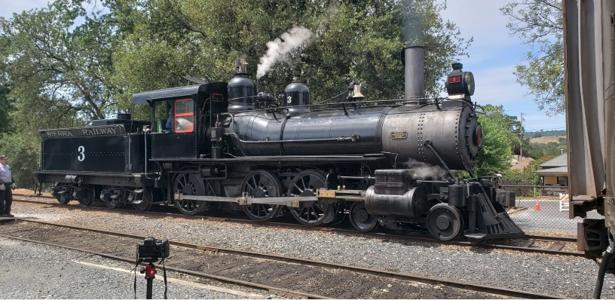

Sierra Number 3 after extensive restoration, now stored at Railtown 1897

The Number 18 quickly took up the movie work slack when Number 3 was semi-retired, and became the go to locomotive for movie work for the next 20 or so years. By 1952 she needed a complete and expensive rebuild and was considered just too old and tired. She was retired, and eventually sold in 1966. Her tender was removed for use on another locomotive, and she was taken apart for restoration. Unfortunately, that restoration never occurred, and she sat in terrible condition, uncovered, in a yard in Central Oregon for many years. But at least she survived, because several Sierra steam locomotives ultimately met the scrapper’s torch.

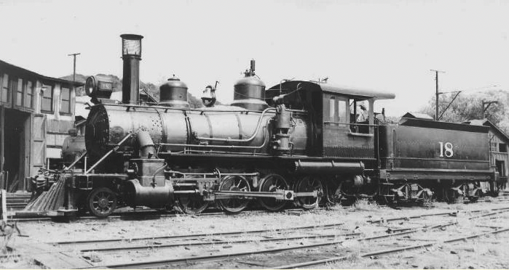

Sierra Number 18, still exists but is in pieces, stored in Garibaldi, Oregon

By 1947, the Number 3 had managed to survive the WWII scrap iron drives, and was still languishing by the Jamestown roundhouse. Along came movie producer David O. Selznick. He made a proposal to the railroad that he would like to film an actual locomotive collision for a movie, and thought the derelict old Number 3 would be a perfect candidate for destruction. Sierra Railroad’s Master Mechanic (who loved steam locomotives) Bill Tremewan was outraged! He convinced the railroad to allow the shop crew to completely restore the old gal, instead of destroying her. They allowed him to do so, and the newly restored Number 3 soon became the apple of every movie producer’s eye. She was also used for excursions and special promotion events. The Number 5 and Number 6 shorty cars from the Angel’s Branch were cleaned up and kept with the Number 3, together designated as “The Movie Train.”

Lots of television shows used the Movie Train. In the 1960’s it became the Cannonball Express for the hit TV show Petticoat Junction. The train appeared in the opening credits, and viewers could hardly miss the sight of Billy Jo, Bobby Jo, and Betty Jo Bradley swimming naked (supposedly) in the Jamestown Depot’s water tank. The train also regularly appeared in Green Acres, a Petticoat Junction spin off series. The train ultimately appeared in many TV shows including The Wild Wild West, Bonanza, The Virginian, Rawhide, and Little House on the Prarie. Michael Landon, the star and producer of Little House was one of the stars of Bonanza. That is where he first saw the Number 3, and he fell immediately in love with the old gal. He loved to include her whenever he could in his productions.

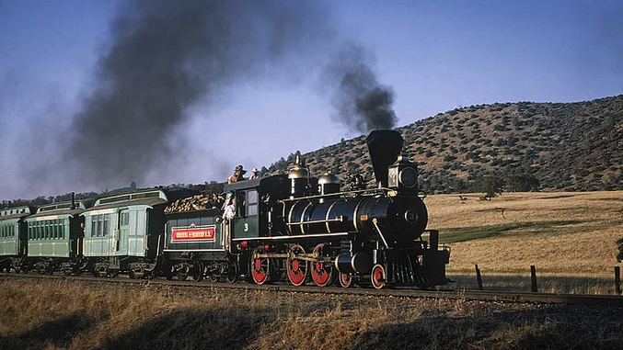

The Movie Train

Among the famous films made using Sierra equipment is High Noon, starring Gary Cooper. Mr. Cooper starred in more films using the Sierra Railroad than any other actor. Clint Eastwood was also a fan of the Sierra, first encountering it during production of the Rawhide TV series, and later using it in his Academy Award winning film Unforgiven. Another famous film, Back to the Future lll, not only starred Number 3, but was largely filmed on the railroad south of Jamestown. Number 3 was not actually operable during filming, but was powered by a generator and powered axles fitted on a flatcar with a fake load on it. Steam and smoke were piped into the proper locations and at the proper timing to give the locomotive the appearance of a full head of steam. The production company even built a futuristic Jules Verne inspired replica of the Number 3 for the last moments of the film.

Ultimately, many Sierra Railroad steam locomotives eventually met the cutting torch. Happily though, a good number of them actually survived! Of course, the Rogers Locomotive Works 4-6-0 Number 3 was completely restored again and is stored at Jamestown, as is Baldwin 2-8-0 Number 28. Both Number 3 and 28 are currently out of service. Both are awaiting their 15 year or 1472 operating days boiler inspections. Number 3 should return to power next year. Number 28’s inspection will commence once Number 3 is finished. Lima Shay Number 12 (used on the steep and twisty Angel’s Branch) is owned by the Pacific Locomotive Association, stored serviceable at Niles Canyon. Baldwin 2-8-0 Number 18 is currently very sad and in many pieces. She was most recently purchased by Oregon Coast Scenic Railroad in Garibaldi Oregon, and awaits restoration. Baldwin 2-6-2 Number 30 is undergoing restoration by the Pacific Locomotive Association at Niles Canyon. Baldwin 2-8-2 Number 34 is now owned by Railtown 1897 Foundation and stored at the Jamestown Roundhouse. She had been owned by a private person for decades, but never left the property and she was donated in 2022 to the Foundation. American Locomotive Works 2-8-2 Number 36 was the last new steam locomotive that the railroad bought. It is now owned by Oregon Coast Scenic Railroad. The huge Baldwin 2-6-6-2 Number 38, Sierra’s biggest steam and only articulated Mallet type locomotive, was built for Weyerhauser Timber Company in 1934. The Sierra purchased her because master Mechanic Bill Tremewan just couldn’t let go of steam locomotives. So, the railroad purchased this huge powerful locomotive at the very end of their steam days, in 1952. She only lasted until 1955 on the Sierra. She worked until 1969 for Rayonier Incorporated in Washington. She is now owned by Oregon Coast Scenic Railroad and is in their Garibaldi shops for restoration.

Bibliography

Books

Deane, Dorothy Newell. Sierra Railway Howell-North, 1960

(Note from Dan …This book is the major source of information for nearly every other Sierra Railroad book. It is amazingly detailed. She is the daughter of Sierra’s head of engineering, William H Newell. She literally lived through the events of this story up to 1960.)

French, Gerald. When Steam Was King. Eureka Publishing, 2006

Jensen, Larry. Hollywood’s Railroads, Volume Two, Sierra Railroad.
Cocheptoa Press. 2018

Johnston, Hank. Thunder in the Mountains. Stauffer Publishing. 1999

Leseer, Josef and Hollywood’s Trains and Trolleys Los Angeles Railroad
Wanamaker, Marc Heritage Found. 2019

Marvin, Judith, Images of America, Jamestown and Western Tuolumne County.
and Brejla, Terry. Arcadia Publishing. 2010

Mikesell, Stephen D. Images of Rail - Sierra Railroad. Arcadia Publishing. 2016

Moore, Jeff. California’s Lumber Shortline Railroads. Fonthill Media LLC. 2016

Rayner, Richard The Associates W.W. Norton & Co. 2009

Starr, Kevin California, A History Modern Library 2015

Wurm, Ted. Yosemite’s Hetch Hetchy Railroad, San Francisco’s Water and Power Project. Stauffer Publishing 2003.

Booklets

Sierra Railway Locomotive Roster. First Edition Railtown 1897 Docent Assoc. 1995

Special Thanks to:

Scott McGhee, General Manager of the Yosemite Mountain Sugar Pine Railroad

Glenn Sutherland, Sierra Railroad historian

Kevin Hecteman, California State Railroad Museum

